Service Qualification REST SPECIFICATION

Document Number: TMF645

Document Version: : <V0.1>

Date: May, 2016

Document Status: Draft

# NOTICE

Copyright © TeleManagement Forum 2013. All Rights Reserved.

This document and translations of it may be copied and furnished to others, and derivative works that comment on or otherwise explain it or assist in its implementation may be prepared, copied, published, and distributed, in whole or in part, without restriction of any kind, provided that the above copyright notice and this section are included on all such copies and derivative works. However, this document itself may not be modified in any way, including by removing the copyright notice or references to TM FORUM, except as needed for the purpose of developing any document or deliverable produced by a TM FORUM Collaboration Project Team (in which case the rules applicable to copyrights, as set forth in the [TM FORUM IPR Policy](http://www.tmforum.org/IPRPolicy/11525/home.html), must be followed) or as required to translate it into languages other than English.

The limited permissions granted above are perpetual and will not be revoked by TM FORUM or its successors or assigns.

This document and the information contained herein is provided on an "AS IS" basis and TM FORUM DISCLAIMS ALL WARRANTIES, EXPRESS OR IMPLIED, INCLUDING BUT NOT LIMITED TO ANY WARRANTY THAT THE USE OF THE INFORMATION HEREIN WILL NOT INFRINGE ANY OWNERSHIP RIGHTS OR ANY IMPLIED WARRANTIES OF MERCHANTABILITY OR FITNESS FOR A PARTICULAR PURPOSE.

Direct inquiries to the TM Forum office:

240 Headquarters Plaza,

East Tower – 10th Floor,

Morristown, NJ  07960 USA

Tel No.  +1 973 944 5100

Fax No.  +1 973 944 5110

TM Forum Web Page: [www.tmforum.org](http://www.tmforum.org/)

TM Forum Web Page: [www.tmforum.org](http://www.tmforum.org/)

# Table of Contents

NOTICE 2

Table of Contents 3

List of Tables 4

Introduction 5

SAMPLE USE CASES 7

RESOURCE MODEL 9

Managed Entity and Task Resource Models 9

Service qualification Resource 10

Product-Offering Qualification Resource 22

Event Models 27

API OPERATION TEMPLATES 29

GET /api/serviceQualification/{ID}/?{filter_and attribute selection} 30

POST /api/serviceQualification 33

POST /api/ProductOfferingQualification 40

GET /api/productOfferingQualification/{ID}/?{filter_and attribute selection} 43

API NOTIFICATION 46

REGISTER LISTENER POST /hub 46

UNREGISTER LISTENER DELETE hub/{id} 46

publish {EventTYPE} POST /listener 47

Release History 49

# List of Tables

Table 1 Service Qualification field description 15

# Introduction

Service Qualification API is One of Pre-Ordering Management API Family. Service Qualification API goal is to provide service availability at Customer location.

In the Open Digital Economy where multiple actors (SDPs, CSPs, …) may be involved with the delivery of an end-to-end service, those actors need to collaborate and interact with the customer as needed.

ServiceQualification API operation checks are modeled as requests:

- serviceQualification request checks technical eligibility (Service Qualification Request resource),

- productOfferingQualification request checks commercial Eligibility include technical eligibility. (productOfferingQualification resource)

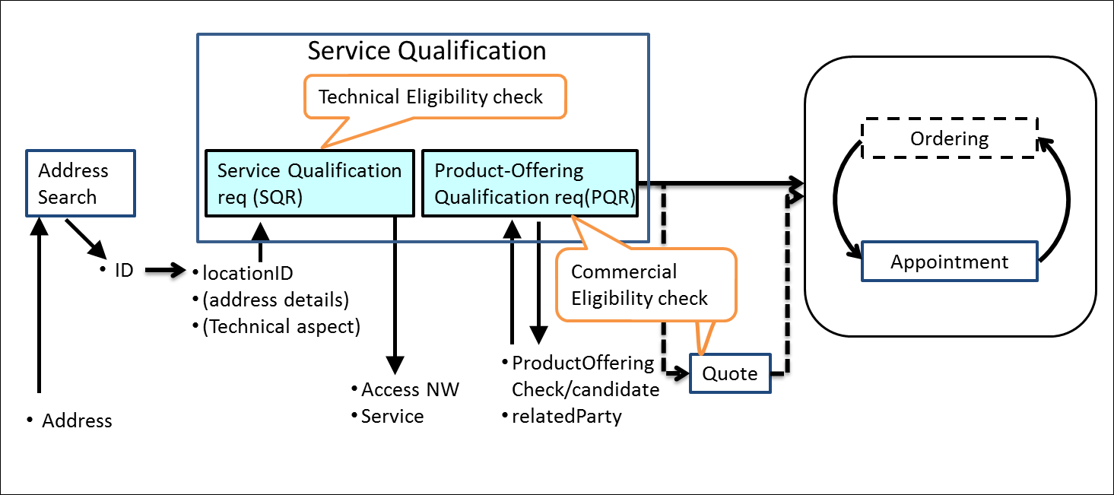

serviceQualificationRequest

* Check if a location (identified by address) is within the service footprint (i.e. within a serving area) and the type of service technology available at the location (i.e. access technology like Fiber, Wireless or Interim Satellite but also sensor data feed or utility service, HDTV availability), where detail response indicates technical parameters of service (e.g. bandwidth, data feed interval and accuracy, pipe diameter for water, etc).
* Intended for use cases where the “middle B[1]” (retail ISP, reseller, etc) is not concerned about the product offering, but only about the service parameters.
* Allows for asynchronous responses via notification hub for checks that take longer.
* Should allow for serviceQualificationRequest for all types of services in a generic way, not only communication service access. If a telecom is sent a serviceQualificationRequest it will respond with the network access technology and parameters available at the location. If an electricity supplier is sent a request, it will respond with the options on electritity (volts?) available at the location, when a water utility is sent a request, it will respond with service parameters available at the location (pipe diameter, pressure, )

productOfferingQualification request

* Check if a given product offering can be delivered to a specific location (identified by address).
* Provide available product offering options if a specific product is not requested/given Synchronous responses only
* Is about product offering level eligibility, where the “middle B” (reseller, etc) is not primarily concerned about technical parameters, but about product offering availability at location.

Depending on the way to describe “Product “, it may be classified in either technical feasibility or commercial feasibility.

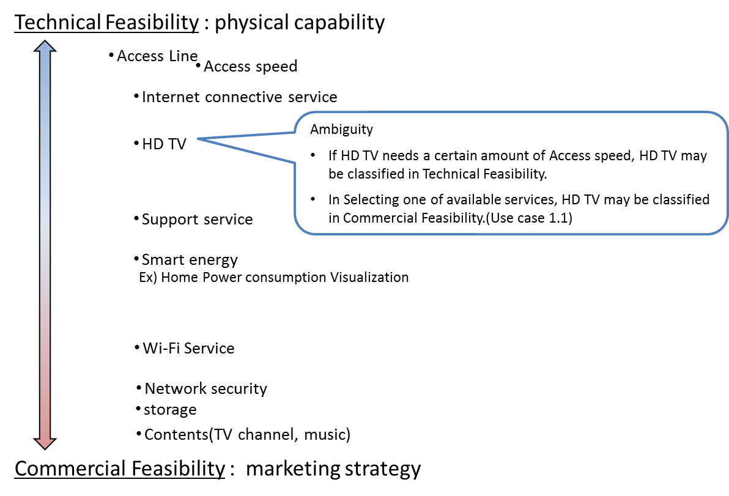

# SAMPLE USE CASES

The following table maps out the use case.

|  |  |
| --- | --- |
| **UC** | **description** |
| 1 | A ‘new’ **customer** is browsing operator internet services webpage and **wish to see** which **offers** he is **eligible** with his current address. The **system** **retrieves** the **list of offers** technically eligible **with characteristics and configuration**. |
| 1.1 | Configuration could be detailed and for example the **customer** is **informed** that he is **eligible** **for** ADSL, TV online but he cannot have both TV HD and Multi-Screen TV options (just **one of these**). |
| 2 | A ‘new’ **customer** is interested for FTTH service – he **asks** to SP sale representative about **FTTH** service at his current address. Thus **system indicate** he is **eligible to FTTH** and he will have a **xx Mo/s speed** for download and yy for upload. |
| 2.2 | Alternative: the address is **ok for FTTH** service but from a strictly technical point of view the operator **FTTH center box** have **not enough space** to plug a new connection. The **Sale** representative is able to **inform** the customer that he will be **eligible to FTTH in 8 week** |
| 3 | a **customer wishes to enjoy HD TV.** He asks to SP sale representative. He is **eligible** but he **has to change** his **access** offer. |
| 3.1 | Alternative: **Access is ok** but system checks that he is currently using an outdated TV decoder and he has to **upgrade** his **TV box** to enjoy HD. |
| 4 | A **customer** **askes for TV on internet.** An eligibility **check** is triggered and should check not only the **TV channel** provided **by the SP** but also the additionally **TV channels availability** at the customer address (even if they not directly provided by the SP). |
| 5 | A **customer** is moving to a new address – a **check** must be done at this new **address** and the **SP** sale representative is able to **inform** the customer if:   * he will be **able to keep** current offer at his new address * he **should downgrade** his services because current ones are not technically feasible at the new address * he can keep but also he is **eligible to** an **upgrade** and benefit for example to a FTTH broadband at his new address. |
| 6 | A **TV channel provider** wants to sell a set of channel for a customer. He will ask for the customer **broadband company** [API provider] and an **access id** (email address for example). He will use this information with this POST /serviceQualificationRequest api to be able to **retrieve** information on customer **access capabilities** (and check if the customer will be able to get his service from the service point). |
| 7 | A **MVNO/other provider** who use provider network will call this api to be able to **check capabilities** for one prospect. With this api he will have all technical information and he should have to apply his own commercial rules to make a proposal to this customer. This UC could be a mandatory one for contractual reason where network is still owned by legacy Telco Company but they have to open it for competitors. |
| 8 | this api could be used in **internal channel** to be able to check technical **capabilities** without any commercial filter. It could be useful in some customer support UC. |
| 9 | a A customer wishes to enjoy different products over multiple accesses. For example: HD TV, internet by fiber and phone service on ADSL. Customer is interested on the commercial offering and not on technical aspects so she calls to a sales representative for that. |

# RESOURCE MODEL

## Managed Entity and Task Resource Models

Service Qualification API has 2 Resources (subclassing Business Interaction).

Service Qualification Request resource for knowing the allowed services based on specific criterions such as

* [IN] location
* [OUT] Access NW
* [OUT] Service

productOfferingQualification resource for knowing the product offering based on specific criterions such as

* [IN/OUT]ProductOffering
* [IN] location (optional)
* [IN]related party (cf. party id, channel)

Here is the state machine diagram for a qualification. Each qualification states are described in the tab below.

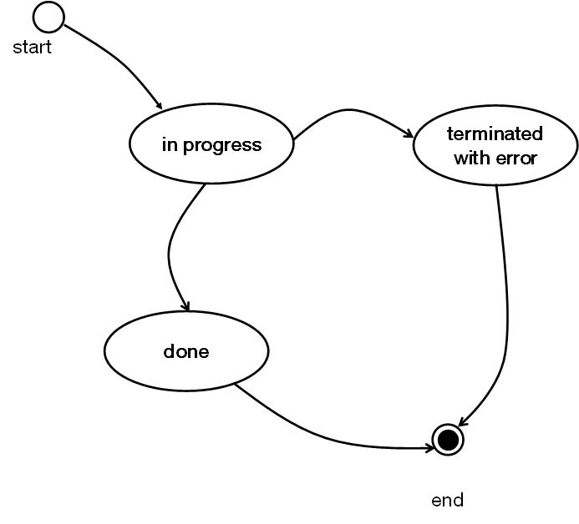

|  |  |
| --- | --- |
| qualification State | Significance |
| In Progress | the qualification is still pending – the supplier has not yet make the qualification request |
| Done | the qualification has been done and the result is available in the qualification resource |
| Terminated with Error | The qualification has been done but there are some errors and result could be incomplete. |

### Service qualification Resource

4 Example of the JSON representation of Service Qualification:

1 of Address, Address description, geoCode and publicKey should be provided

1. Address id for location info
2. Address discription for location info
3. Geocode for location info
4. Public-key for location info

Service provider execute service qualification request with location information to get technical eligibility that is network access speed, available service list.

1. Address id for location info

|  |
| --- |
| {  "id": "42",  "href": "http::..//serviceQualification/42",  "interactionDate": "20160201 10:00",  "provideAlternative": "No",  "provideOnlyEligible": "Yes",  "description": "exmple of a qualification task",  "eligibilityDate": "20160201 10:00",  "qualificationState": "InProgress",  "address": {  "id": "12345678",  "href": "https://www.google.ca/maps/dir/''/google+map+montreal+place+ville+marie/@45.5014452,-73.6393962,12z/data=!3m1!4b1!4m8!4m7!1m0!1m5!1m1!1s0x4cc91a4498f8f3db:0xa2760b4a779d61d3!2m2!1d-73.5693564!2d45.5014666"  },  "physicalTerminationPoint": [  {"accessType": "ADSL"},  {"accessType": "Fiber"}  ],  "serviceQualificationItem": [  {  "service": {  "id": "string",  "href": "string",  "name": "string",  "serviceCharacteristic": [{  "name": "string",  "value": "string"  }],  "serviceSpecification": {  "id": "2222",  "href": "https://serviceSpecification/ADSL",  "serviceCategoryId": "TVservice",  "serviceSpecificationCharacteristic": [  {  "id": "2211",  "name": "upstreamSpeed",  "valuefrom": "10KBPS",  "valueto": "1MBPS"  },  {  "id": "2212",  "name": "downstreamSpeed",  "valuefrom": "100KBPS",  "valueto": "6MBPS"  }  ]  }  },  "availability": "available",  "serviceabilityDate": "20160201 10:00"  },  {  "service": {  "id": "string",  "href": "string",  "name": "string",  "serviceCharacteristic": [{  "name": "string",  "value": "string"  }],  "serviceSpecification": {  "id": "2222",  "href": "https://serviceSpecification/ADSL",  "serviceCategoryId": "TVservice",  "serviceSpecificationCharacteristic": [  {  "id": "2211",  "name": "upstreamSpeed",  "valuefrom": "10KBPS",  "valueto": "1MBPS"  },  {  "id": "2212",  "name": "downstreamSpeed",  "valuefrom": "100KBPS",  "valueto": "6MBPS"  }  ]  }  },  "availability": "available",  "serviceabilityDate": "20160201 10:00"  }  ] } |

1. Address discription for location info

|  |
| --- |
| {  "id": "42",  "href": "http::..//serviceQualification/42",  "interactionDate": "20160201 10:00",  "provideAlternative": "No",  "provideOnlyEligible": "Yes",  "description": "exmple of a qualification task",  "eligibilityDate": "20160201 10:00",  "qualificationState": "InProgress",  "addressDescription": {  "streetNr": "1",  "streetName": "ville Marie",  "city": "montreal",  "stateOrProvince": "Quebec",  "country": "Canada "  },  "physicalTerminationPoint": [  {"accessType": "ADSL"},  {"accessType": "Fiber"}  ],  "serviceQualificationItem": [  {  "service": {  "id": "string",  "href": "string",  "name": "string",  "serviceCharacteristic": [{  "name": "string",  "value": "string"  }],  "serviceSpecification": {  "id": "2222",  "href": "https://serviceSpecification/ADSL",  "serviceCategoryId": "TVservice",  "serviceSpecificationCharacteristic": [  {  "id": "2211",  "name": "upstreamSpeed",  "valuefrom": "10KBPS",  "valueto": "1MBPS"  },  {  "id": "2212",  "name": "downstreamSpeed",  "valuefrom": "100KBPS",  "valueto": "6MBPS"  }  ]  }  },  "availability": "available",  "serviceabilityDate": "20160201 10:00"  },  {  "service": {  "id": "string",  "href": "string",  "name": "string",  "serviceCharacteristic": [{  "name": "string",  "value": "string"  }],  "serviceSpecification": {  "id": "2222",  "href": "https://serviceSpecification/ADSL",  "serviceCategoryId": "TVservice",  "serviceSpecificationCharacteristic": [  {  "id": "2211",  "name": "upstreamSpeed",  "valuefrom": "10KBPS",  "valueto": "1MBPS"  },  {  "id": "2212",  "name": "downstreamSpeed",  "valuefrom": "100KBPS",  "valueto": "6MBPS"  }  ]  }  },  "availability": "available",  "serviceabilityDate": "20160201 10:00"  }  ] } |

1. Geocode for location info

|  |
| --- |
| {  "id": "42",  "href": "http::..//serviceQualification/42",  "interactionDate": "20160201 10:00",  "provideAlternative": "No",  "provideOnlyEligible": "Yes",  "description": "exmple of a qualification request",  "eligibilityDate": "20160201 10:00",  "qualificationState": "InProgress",  "geocode": {  "latitude": "73.6393962",  "longitude": "45.5014452"  },  "physicalTerminationPoint": [  {"accessType": "ADSL"},  {"accessType": "Fiber"}  ],  "serviceQualificationItem": [  {  "service": {  "id": "string",  "href": "string",  "name": "string",  "serviceCharacteristic": [{  "name": "string",  "value": "string"  }],  "serviceSpecification": {  "id": "2222",  "href": "https://serviceSpecification/ADSL",  "serviceCategoryId": "TVservice",  "serviceSpecificationCharacteristic": [  {  "id": "2211",  "name": "upstreamSpeed",  "valuefrom": "10KBPS",  "valueto": "1MBPS"  },  {  "id": "2212",  "name": "downstreamSpeed",  "valuefrom": "100KBPS",  "valueto": "6MBPS"  }  ]  }  },  "availability": "available",  "serviceabilityDate": "20160201 10:00"  },  {  "service": {  "id": "string",  "href": "string",  "name": "string",  "serviceCharacteristic": [{  "name": "string",  "value": "string"  }],  "serviceSpecification": {  "id": "2222",  "href": "https://serviceSpecification/ADSL",  "serviceCategoryId": "TVservice",  "serviceSpecificationCharacteristic": [  {  "id": "2211",  "name": "upstreamSpeed",  "valuefrom": "10KBPS",  "valueto": "1MBPS"  },  {  "id": "2212",  "name": "downstreamSpeed",  "valuefrom": "100KBPS",  "valueto": "6MBPS"  }  ]  }  },  "availability": "available",  "serviceabilityDate": "20160201 10:00"  }  ] } |

1. Public-key for location info

|  |
| --- |
| {  "id": "42",  "href": "http::..//serviceQualification/42",  "interactionDate": "20160201 10:00",  "provideAlternative": "No",  "provideOnlyEligible": "Yes",  "description": "exmple of a qualification request",  "eligibilityDate": "20160201 10:00",  "qualificationState": "InProgress",  "publicKey": "public-Key_ 00000000",  "physicalTerminationPoint": [  {"accessType": "ADSL"},  {"accessType": "Fiber"}  ],  "serviceQualificationItem": [  {  "service": {  "id": "string",  "href": "string",  "name": "string",  "serviceCharacteristic": [{  "name": "string",  "value": "string"  }],  "serviceSpecification": {  "id": "2222",  "href": "https://serviceSpecification/ADSL",  "serviceCategoryId": "TVservice",  "serviceSpecificationCharacteristic": [  {  "id": "2211",  "name": "upstreamSpeed",  "valuefrom": "10KBPS",  "valueto": "1MBPS"  },  {  "id": "2212",  "name": "downstreamSpeed",  "valuefrom": "100KBPS",  "valueto": "6MBPS"  }  ]  }  },  "availability": "available",  "serviceabilityDate": "20160201 10:00"  },  {  "service": {  "id": "string",  "href": "string",  "name": "string",  "serviceCharacteristic": [{  "name": "string",  "value": "string"  }],  "serviceSpecification": {  "id": "2222",  "href": "https://serviceSpecification/ADSL",  "serviceCategoryId": "TVservice",  "serviceSpecificationCharacteristic": [  {  "id": "2211",  "name": "upstreamSpeed",  "valuefrom": "10KBPS",  "valueto": "1MBPS"  },  {  "id": "2212",  "name": "downstreamSpeed",  "valuefrom": "100KBPS",  "valueto": "6MBPS"  }  ]  }  },  "availability": "available",  "serviceabilityDate": "20160201 10:00"  }  ] } |

Fields Description

ServiceQualification

| Field | Description |
| --- | --- |
| id | Unique identifier for Interaction. |
| eligibilityDate | The Date requested eligibility |
| address |  |
| type | Type of place |
| td | Unique identifier for Place |
| href | Reference of a place (for instance in google map) |
| address description | Address description |
| streetNr | number identifying a specific property on a public street. It may be combined with streetNrLast for ranged addresses |
| streetNrSuffix | the first street number suffix |
| streetName | the name of the street or other street type |
| streetType | alley, avenue, boulevard, brae, crescent, drive, highway, lane, terrace, parade, place, tarn, way, wharf ? |
| streetSuffix | A modifier denoting a relative direction |
| city | the City that the address is in |
| locality | "An area of defined or undefined boundaries within a local authority or other legislatively defined area, usually rural or semi rural in nature." [ANZLIC-STREET], or a suburb "a bounded locality within a city, town or shire principally of urban character " [ANZLIC-STREET] |
| postcode | A descriptor for a postal delivery area, used to speed and simplify the delivery of mail |
| stateOrProvince | the State or Province that the address is in |
| country | the Country that the address is in |
| geoCode | Geographic code |
| latitude | Latitude |
| longitude | Longitude |
| geographicDatum | Geocoding referential |
| publicKey | a landline number or an internet access id |
| serviceSpecification | Requested service specification |
| id | Unique identifier for serviceSpecification |
| serviceCharacteristic |  |
| id | Servicecharactristic for requested service |
| value | serviceCharacteristic value for requested service |
| serviceCategory |  |
| id | Unique identifier for serviceCategory |
| provideAlternative | if this flag I set to Yes - the API will retrieve closest value available for this same service |
| provideOnlyEligible | used to restrict API response to only available services.  If this flag is set to No the API will provide both positive and negative eligibility results. |
| terminationError | if qualification has not been done properly we indicate there termination error |
| id |  |
| value | Unique identifier for terminationError |

| Field | Description |
| --- | --- |
| id | Unique identifier for Interaction. |
| eligibilityDate |  |
| address |  |
| type | Type of place |
| id | Unique identifier for Place |
| href | Reference of a place (for instance in google map) |
| publicKey | a landline number or an internet access id |
| physicalResource | Array of physical resource for multiple access NW |
| physicalTerminationPoint | Logical resource for multiple access NW |
| accessType | Access Technology Type: ADSL, VDSL, fiber |
| serviceSpecification | Service specification for qualification service |
| id | Unique identifier for Service specification |
| serviceCategoryId | Category id for requested service |
| serviceSpecificationCharacteristic | Characteristic for requested service |
| id | Unique identifier for |
| value |  |
| serviceQualification | services with a specific eligibility check will be listed there with technical eligibility result |
| qualificationResult | Technical eligibility result: service availability status which explain below |
| comment | Comment for technical eligibility result |
| qualificationResultDate | qualification judgement date |
| terminationError | if qualification has not been done properly we indicate there termination error |
| id | Unique identifier for terminationError |
| value |  |

Table 1 Service Qualification field description

Serviceability status may be represented the following table.

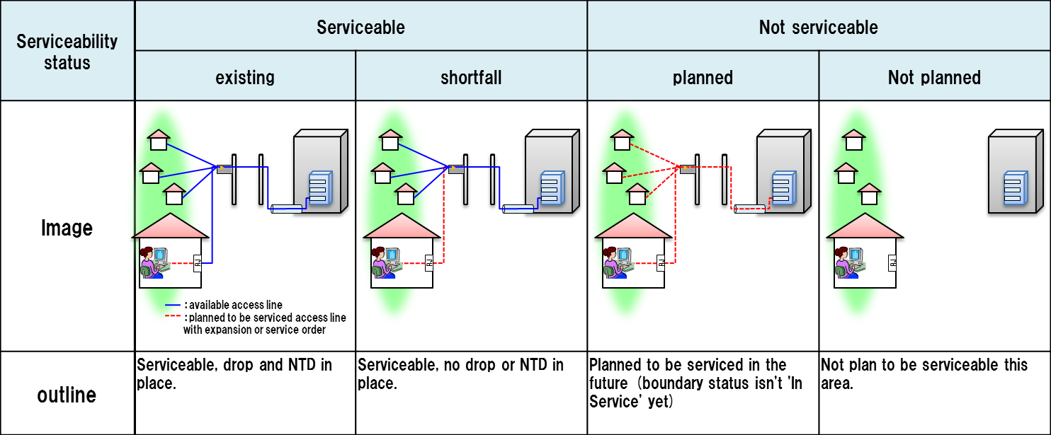

serviceable-shortfall is include updating access NW.

substatus are captured via notation i.e serviceable.existing etc…

In the case that the service provider or broker responding to the request already knows about an upcoming change in the serviceability status, it is intended that the response is sent as a collection of the about results, listing both the current and the future valid response with its state and a matching eligibility date.

### Product-Offering Qualification Resource

Example of the JSON representation of Product-Offering Qualification:

Service provider execute Product-Offering Qualification task to get the customer location Feasibility include Commercial and Technical eligibility.

|  |
| --- |
| {  "id": "42",  "href": "http::..//productOfferingQualification/42",  "interactionDate": "20160201 10:00",  "description": "exmple of a qualification task",  "eligibilityDate": "20160201 10:00",  "qualificationState": "InProgress",  "productInventoryId": "ADSL_locate_No",  "provideOnlyAvailable": "No",  "provideUnavailabilityReason": "Yes",  "partyId": "service_provider_0001",  "channel": "web store",  "address": {"id": "12345678"},  "productOfferingQualificationItem": [  {  "productOffering": {  "id": "42",  "href": "http: //serverlocation: port/catalogManagement/productOffering/42",  "category": {"id": "TVservice with Internet Play"},  "product": {  "productSpecification": {  "id": "13",  "href": "http://serverlocation:port/catalogManagement/productSpecification/13",  "version": "2.0",  "name": "specification product 1"  },  "productCharacteristic": [{  "id": "downstreamspeed",  "value": "10MBPS"  }]  }  },  "orderFeasibilityCheck": {"eligibilityResult": "available"}  },  {  "productOffering": {  "id": "42",  "href": "http: //serverlocation: port/catalogManagement/productOffering/42",  "category": {"id": "TVservice with Internet Play"},  "product": {  "productSpecification": {  "id": "13",  "href": "http://serverlocation:port/catalogManagement/productSpecification/13",  "version": "2.0",  "name": "specification product 1"  },  "productCharacteristic": [{  "id": "downstreamspeed",  "value": "6MBPS"  }]  }  },  "orderFeasibilityCheck": {  "eligibilityResult": "unavailable",  "eligibilityUnavailablityReason": [{  "code": "UNAVAILABLE-300",  "label": "need more bandwidth"  }]  }  }  ] } |

For each resource in your model fill the following table.

Fields Description

ProductOfferingQualification

| Field | Description |
| --- | --- |
| partyId | Unique identifier for party |
| channel | Channel |
| productInventoryId | Product Inventory ID for commercial eligibility |
| address |  |
| id | Unique identifier for Place |
| href | Reference of a place (for instance in google map) |
| address description | Address description |
| streetNr | number identifying a specific property on a public street. It may be combined with streetNrLast for ranged addresses |
| streetNrSuffix | the first street number suffix |
| streetName | the name of the street or other street type |
| streetType | alley, avenue, boulevard, brae, crescent, drive, highway, lane, terrace, parade, place, tarn, way, wharf ? |
| streetSuffix | A modifier denoting a relative direction |
| city | the City that the address is in |
| locality | "An area of defined or undefined boundaries within a local authority or other legislatively defined area, usually rural or semi rural in nature." [ANZLIC-STREET], or a suburb "a bounded locality within a city, town or shire principally of urban character " [ANZLIC-STREET] |
| postcode | A descriptor for a postal delivery area, used to speed and simplify the delivery of mail |
| stateOrProvince | the State or Province that the address is in |
| country | the Country that the address is in |
| geoCode | Geographic code |
| latitude | Latitude |
| longitude | Longitude |
| geographicDatum | Geocoding referential |
| publicKey | a landline number or an internet access id |
| productOfferingSpecification | Requested product-offering specification |
| id | Unique identifier of product-offering specification |
| productOfferingCategory | Requested product-offering category |
| id | Unique identifier of product-offering category |
| productOfferingCharacteristic | A characteristic quality or distinctive feature of a product-Offering |
| id | Unique identifier of productOfferingCharacteristic |
| value |  |
| provideOnlyAvailable | If this flag is set to No the API will provide both positive and negative availability results. |
| provideUnavailabilityReason | add in the API the rational for not-authorized productOffering. The rationales for non-authorized are described in the eligibilityUnvailabilityReason structure in the response. |
|  |  |

| Field | Description |
| --- | --- |
| productOfferingSpecification |  |
| id | ID of the top level productOffering |
| productOfferingCategoryId | Unique identifier for productOfferingCategory |
| productCharacteristic |  |
| id | Unique identifier for productCharacteristic |
| value | The value for productCharacteristic in this productOffering |
| orderFeasibilityCheck | Commercial and Technical eligibility result for this offer: |
| eligibilityResult | Eligibility result for this offer |
| eligibilityUnavailabilityReason | reason for eligibility result if the offer was unavailable |
| code | Unavailable reason code |
| label | Unavailable reason label |
| terminationError | if qualification has not been done properly we indicate there termination error |
| id | Unique identifier for termination error |
| value |  |

For each resource in the API provide a UML model:

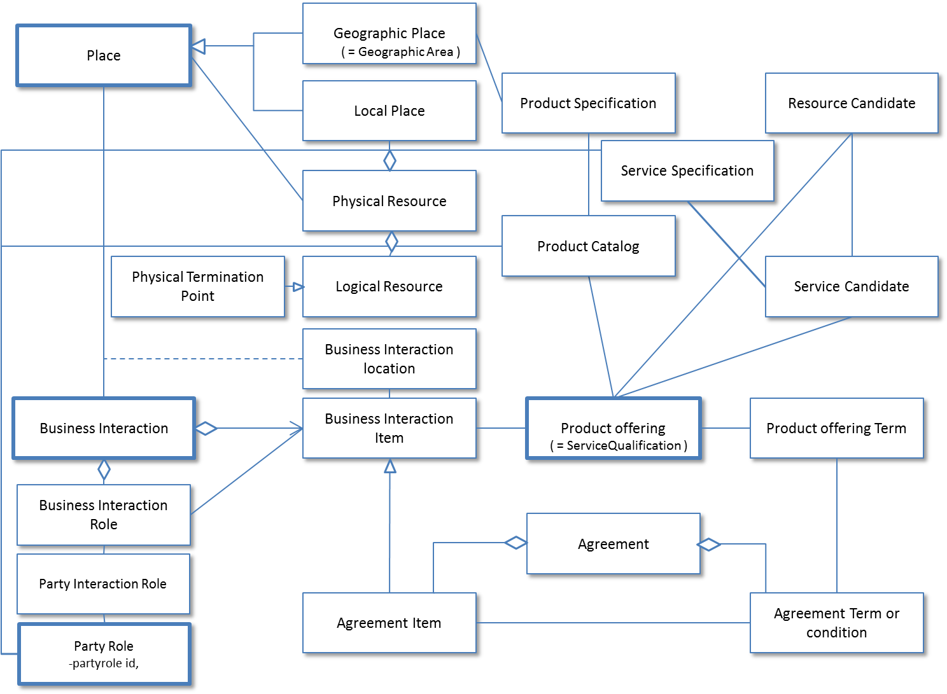

Figure 1 – Service Qualification resource model

# Event Models

The Service Qualification API supports a single event called QualificationStateChange Notification.This event is used to track the qualificationState of a service or product offering qualification.

|  |
| --- |
| {  "event": {    "id": "42",  "href": "http::..//productOfferingQualification/42",  "interactionDate": "20160201 10:00",  "description": "exmple of a qualification task",  "eligibilityDate": "20160201 10:00",  "qualificationState": "Done",  "productInventoryId": "ADSL_locate_No",  "provideOnlyAvailable": "No",  "provideUnavailabilityReason": "Yes",  "partyId": "service provider A",  "channel": "web store",  "address": {"id": "12345678"},  "productOfferingQualificationItem": [{  "productOffering": {  "id": "42",  "href": "http: //serverlocation: port/catalogManagement/productOffering/42",  "category": {"id": "TVservice with Internet Play"},  "product": {  "productSpecification": {  "id": "13",  "href": "http://serverlocation:port/catalogManagement/productSpecification/13",  "version": "2.0",  "name": "TVservice with Internet Play"  },  "productCharacteristic": [  {  "id": "upstreamspeed",  "value": "1 MBPS"  },  {  "id": "downstreamspeed",  "value": "6 MBPS"  }  ]  }  },  "orderFeasibilityCheck": {"eligibilityResult": "available"}  }] }  }  },  "eventType": "QualificationStateChange" } |

# API OPERATION TEMPLATES

For every single of operation on the entities use the following templates and provide sample REST requests and responses.

Remember that the following Uniform Contract rules must be used :

|  |  |  |
| --- | --- | --- |
| Operation on Entities | Uniform API Operation | Description |
| Query Entities | GET Resource | GET must be used to retrieve a representation of a resource. |
| Create Entity | POST Resource | POST must be used to create a new resource |
| Partial Update of an Entity | PATCH Resource | PATCH must be used to partially update a resource |
| Complete Update of an Entity | PUT Resource | PUT must be used to completely update a resource identified by its resource URI |
| Remove an Entity | DELETE Resource | DELETE must be used to remove a resource |
| Execute an Action on an Entity | POST on TASK Resource | POST must be used to execute Task Resources |
| Other Request Methods | POST on TASK Resource | GET and POST must not be used to tunnel other request methods. |

Filtering and attribute selection rules are described in the TMF REST Design Guidelines.

Notifications are also described in a subsequent section.

## GET /api/serviceQualification/{ID}/?{filter_and attribute selection}

Description :

This operation is used to retrieve current serviceQualification tasks.

GET operation use if location id is created at other API/system.

Behavior :

* Return status codes
  + 200 OK – the request was successful
  + 400 Bad Request – error, for example to cover these functional error cases:
    - Location is not exist

|  |
| --- |
| **REQUEST** |
| GET /api/serviceQualification/42  Accept: application/json |
| **RESPONSE** |
| 200  Content-Type: application/json  {  "id": "42",  "href": "http::..//serviceQualification/42",  "interactionDate": "20160201 10:00",  "provideAlternative": "No",  "provideOnlyEligible": "Yes",  "description": "exmple of a qualification task",  "eligibilityDate": "20160201 10:00",  "qualificationState": "InProgress",  "address": {  "id": "12345678",  "href": "https://www.google.ca/maps/dir/''/google+map+montreal+place+ville+marie/@45.5014452,-73.6393962,12z/data=!3m1!4b1!4m8!4m7!1m0!1m5!1m1!1s0x4cc91a4498f8f3db:0xa2760b4a779d61d3!2m2!1d-73.5693564!2d45.5014666"  },  "addressDescription": {  "streetNr": "1",  "streetName": "ville Marie",  "city": "montreal",  "stateOrProvince": "Quebec",  "country": "Canada "  },  "geocode": {  "latitude": "73.6393962",  "longitude": "45.5014452"  },  "publicKey": "public-Key_ 00000000",  "physicalTerminationPoint": [  {"accessType": "ADSL"},  {"accessType": "Fiber"}  ],  "serviceQualificationItem": [  {  "service": {  "id": "string",  "href": "string",  "name": "string",  "serviceCharacteristic": [{  "name": "string",  "value": "string"  }],  "serviceSpecification": {  "id": "2222",  "href": "https://serviceSpecification/ADSL",  "serviceCategoryId": "TVservice",  "serviceSpecificationCharacteristic": [  {  "id": "2211",  "name": "upstreamSpeed",  "valuefrom": "10KBPS",  "valueto": "1MBPS"  },  {  "id": "2212",  "name": "downstreamSpeed",  "valuefrom": "100KBPS",  "valueto": "6MBPS"  }  ]  }  },  "availability": "available",  "serviceabilityDate": "20160201 10:00"  },  {  "service": {  "id": "string",  "href": "string",  "name": "string",  "serviceCharacteristic": [{  "name": "string",  "value": "string"  }],  "serviceSpecification": {  "id": "2222",  "href": "https://serviceSpecification/ADSL",  "serviceCategoryId": "TVservice",  "serviceSpecificationCharacteristic": [  {  "id": "2211",  "name": "upstreamSpeed",  "valuefrom": "10KBPS",  "valueto": "1MBPS"  },  {  "id": "2212",  "name": "downstreamSpeed",  "valuefrom": "100KBPS",  "valueto": "6MBPS"  }  ]  }  },  "availability": "available",  "serviceabilityDate": "20160201 10:00"  }  ] } |

## POST /api/serviceQualification

Description :

This operation creates a Task to provide technical Eligibility that is what service is available or when the service is available.

Partner used this API to notice service availability Partner’s customer.

POST operation use if location id is create at this operation.

|  |  |  |  |
| --- | --- | --- | --- |
| **Attribute name** | **Mandatory** | **Default** | **Rule** |
| Id | N | Blank |  |
| eligibilityDate | N | Today |  |
| Address | N |  | Address info need one from any address representaions |
| Address description | N |  | Address info need one from any address representaions |
| geoCode | N |  | Address info need one from any address representaions |
| publicKey | N |  | Address info need one from any address representaions |
| serviceSpecification | N |  |  |
| serviceCharacteristic | N |  |  |
| serviceCategory | N |  |  |
| provideAlternative | N | “No” | if this flag I set to Yes - the API will retrieve closest value available for this same service |
| provideOnlyEligible | N | “Yes” | If this flag is set to No the API will provide both positive and negative eligibility results |

Behavior :

* Return status codes
  + 201 OK – the request was successful
  + 400 Bad Request – error, for example to cover these functional error cases:
    - Location is not exist

Use case :

3 Examples for a Specific Service

* with Location
* with Location and Physical Characteristics
* with Service Specification and Characteristics

We assume requests are synchronous (i.e. responses are sent synchronously)

1) Which services can be provided at a specific location?

|  |
| --- |
| **REQUEST** |
| POST /api/serviceQualification  Accept: application/json  {  “address” : {  “href” : “https://www.google.ca/maps/dir/''/google+map+montreal+place+ville+marie/@45.5014452,-73.6393962,12z/data=!3m1!4b1!4m8!4m7!1m0!1m5!1m1!1s0x4cc91a4498f8f3db:0xa2760b4a779d61d3!2m2!1d-73.5693564!2d45.5014666”  }  } |
| **RESPONSE** |
| 201  Content-Type: application/json  {  "id": "42",  "href": "http::..//serviceQualification/42",  "interactionDate": "20160201 10:00",  "provideAlternative": "No",  "provideOnlyEligible": "Yes",  "description": "exmple of a qualification task",  "eligibilityDate": "20160201 10:00",  "qualificationState": "InProgress",  "address": {  "href": "https://www.google.ca/maps/dir/''/google+map+montreal+place+ville+marie/@45.5014452,-73.6393962,12z/data=!3m1!4b1!4m8!4m7!1m0!1m5!1m1!1s0x4cc91a4498f8f3db:0xa2760b4a779d61d3!2m2!1d-73.5693564!2d45.5014666"  },   "publicKey": "public-Key_ 00000000",  "physicalTerminationPoint": [  {"accessType": "ADSL"},  {"accessType": "Fiber"}  ],  "serviceQualificationItem": [  {  "service": {  "id": "string",  "href": "string",  "name": "string",  "serviceCharacteristic": [{  "name": "string",  "value": "string"  }],  "serviceSpecification": {  "id": "2222",  "href": "https://serviceSpecification/ADSL",  "serviceCategoryId": "TVservice",  "serviceSpecificationCharacteristic": [  {  "id": "2211",  "name": "upstreamSpeed",  "valuefrom": "10KBPS",  "valueto": "1MBPS"  },  {  "id": "2212",  "name": "downstreamSpeed",  "valuefrom": "100KBPS",  "valueto": "6MBPS"  }  ]  }  },  "availability": "available",  "serviceabilityDate": "20160201 10:00"  },  {  "service": {  "id": "string",  "href": "string",  "name": "string",  "serviceCharacteristic": [{  "name": "string",  "value": "string"  }],  "serviceSpecification": {  "id": "2222",  "href": "https://serviceSpecification/ADSL",  "serviceCategoryId": "TVservice",  "serviceSpecificationCharacteristic": [  {  "id": "2211",  "name": "upstreamSpeed",  "valuefrom": "10KBPS",  "valueto": "1MBPS"  },  {  "id": "2212",  "name": "downstreamSpeed",  "valuefrom": "100KBPS",  "valueto": "6MBPS"  }  ]  }  },  "availability": "available",  "serviceabilityDate": "20160201 10:00"  }  ] } |

2) can the access NW be provided at a specific location

|  |
| --- |
| **REQUEST** |
| POST /api/serviceQualificationRequest  Accept: application/json  {  "id": "42",  "interactionDate": "20160201 10:00",  "provideAlternative": "No",  "provideOnlyEligible": "Yes",  "description": "exmple of a qualification task",  "eligibilityDate": "20160201 10:00",  "address": {"href": "https://www.google.ca/maps/dir/''/google+map+montreal+place+ville+marie/@45.5014452,-73.6393962,12z/data=!3m1!4b1!4m8!4m7!1m0!1m5!1m1!1s0x4cc91a4498f8f3db:0xa2760b4a779d61d3!2m2!1d-73.5693564!2d45.5014666"},  "serviceQualificationItem": [{"service": {  "serviceCharacteristic": [{  "name": "downstreamspeed",  "value": "10 Mbps"  }],  "serviceSpecification": {  " id": "2233",  "href": "http://serviceSpecification/FiberAccess",  "serviceCategoryId": "FiberAccess"  }  }}] } |
| **RESPONSE** |
| 201  Content-Type: application/json  {  "id": "42",  "href": "http::..//serviceQualification/42",  "interactionDate": "20160201 10:00",  "provideAlternative": "No",  "provideOnlyEligible": "Yes",  "description": "exmple of a qualification task",  "eligibilityDate": "20160201 10:00",  "qualificationState": "InProgress",  "address": {"href": "https://www.google.ca/maps/dir/''/google+map+montreal+place+ville+marie/@45.5014452,-73.6393962,12z/data=!3m1!4b1!4m8!4m7!1m0!1m5!1m1!1s0x4cc91a4498f8f3db:0xa2760b4a779d61d3!2m2!1d-73.5693564!2d45.5014666"},  "serviceQualificationItem": [{  "service": {  "serviceCharacteristic": [{  "name": "downstreamspeed",  "value": "10 Mbps"  }],  "serviceSpecification": {  " id": "2233",  "href": "http://serviceSpecification/FiberAccess",  "serviceCategoryId": "FiberAccess",  "serviceSpecificationCharacteristic": [  {  "name": "uploadSpeed",  "valuefrom": "100 KBPS",  "valueto": "1 GBPS"  },  {  "name": "downloadSpeed",  "valuefrom": "1 MBPS",  "valueto": "5 GBPS"  }  ]  }  },  "availability": "available-shortfall",  "serviceabilityDate": "20160201 10:00"  }] } |

3) can the specific service be provided at a specific location

|  |
| --- |
| **REQUEST** |
| POST /api/serviceQualification  Accept: application/json  {  "id": "42",  "interactionDate": "20160201 10:00",  "provideAlternative": "No",  "provideOnlyEligible": "Yes",  "description": "exmple of a qualification task",  "eligibilityDate": "20160201 10:00",  "address": {"href": "https://www.google.ca/maps/dir/''/google+map+montreal+place+ville+marie/@45.5014452,-73.6393962,12z/data=!3m1!4b1!4m8!4m7!1m0!1m5!1m1!1s0x4cc91a4498f8f3db:0xa2760b4a779d61d3!2m2!1d-73.5693564!2d45.5014666"},  "serviceQualificationItem": [{"service": {"serviceCharacteristic": [  {  "name": "upstreamSpeed",  "value": "1Mbps"  },  {  "name": "downstreamSpeed",  "value": "100Mbps"  }  ]}}] } |
| **RESPONSE** |
| 201  Content-Type: application/json  {  "id": "42",  "interactionDate": "20160201 10:00",  "provideAlternative": "No",  "provideOnlyEligible": "Yes",  "description": "exmple of a qualification task",  "eligibilityDate": "20160201 10:00",  "physicalTerminationPoint": [  {"accessType": "ADSL"},  {"accessType": "Fiber"}  ],  "address": {"href": "https://www.google.ca/maps/dir/''/google+map+montreal+place+ville+marie/@45.5014452,-73.6393962,12z/data=!3m1!4b1!4m8!4m7!1m0!1m5!1m1!1s0x4cc91a4498f8f3db:0xa2760b4a779d61d3!2m2!1d-73.5693564!2d45.5014666"},  "serviceQualificationItem": [  {  "service": {"serviceSpecification": {  "id": "ADSL",  "href": "https://serviceSpecification/ADSL",  "serviceCategoryId": "Internet",  "serviceSpecificationCharacteristic": [  {  "name": "uploadSpeed",  "valuefrom": "10KBPS",  "valueto": "1MBPS"  },  {  "name": "downloadSpeed",  "valuefrom": "100KBPS",  "valueto": "6MBPS"  }  ]  }},  "availability": "available",  "serviceabilityDate": "20160201 10:00"  },  {  "service": {"serviceSpecification": {  "id": "TVservice",  "href": "https://serviceSpecification/TVservice",  "serviceCategoryId": "TV"  }},  "availability": "available",  "serviceabilityDate": "20160201 10:00"  }  ] } |

## POST /api/productOfferingQualification

Description :

This operation is used to provide commercial eligibility from address information immediately.

i.e Product Offerings (and constraints on ProductOffering pricing).

This operation execute for offering check.

| **Attribute name** | **Mandatory** | **Default** | **Rule** |
| --- | --- | --- | --- |
| partyId | N |  |  |
| channel | N |  |  |
| productInventoryId | N |  |  |
| address | N |  |  |
| Address description | N |  |  |
| geoCode | N |  |  |
| publicKey | N |  |  |
| productOfferingSpecificaion | N |  | Product Offering info need productOfferingSpecificaion or productOfferingCategory |
| productOfferingCategory | N |  | Product Offering info need productOfferingSpecificaion or productOfferingCategory |
| productCharacteristic | N |  |  |
| provideOnlyAvailable | N | “Yes” | If this flag is set to No the API will provide both positive and negative eligibility results |
| provideUnavailabilityReason | N | “No” | This flag is used to add the rational for not-authorized productOffering. |

Behavior :

* Return status codes
  + 201 OK – the request was successful
  + 400 Bad Request – error, for example to cover these functional error cases:
    - Location is not exist

Use case :

Following example is to check commercial eligibility.

Request asks “what product can run through specific service provider”.

|  |
| --- |
| **REQUEST** |
| POST /api/productOfferingQualification  Accept: application/json  Content-Type: application/json  {  "partyId": "service provider A",  "address": {"id": "12345678"},  "productOfferingQualificationItem": [{"productOffering": {"category": {"id": "TV Service with Internet play"}}}] } |
| **RESPONSE** |
| 201  Content-Type: application/json  {  "id": "42",  "href": "http::..//productOfferingQualification/42",  "interactionDate": "20160201 10:00",  "description": "exmple of a qualification task",  "eligibilityDate": "20160201 10:00",  "qualificationState": "InProgress",  "productInventoryId": "ADSL_locate_No",  "provideOnlyAvailable": "No",  "provideUnavailabilityReason": "Yes",  "partyId": "service provider A",  "channel": "web store",  "address": {"id": "12345678"},  "productOfferingQualificationItem": [{  "productOffering": {  "id": "42",  "href": "http: //serverlocation: port/catalogManagement/productOffering/42",  "category": {"id": "TVservice with Internet Play"},  "product": {  "productSpecification": {  "id": "13",  "href": "http://serverlocation:port/catalogManagement/productSpecification/13",  "version": "2.0",  "name": "TVservice with Internet Play"  },  "productCharacteristic": [  {  "id": "upstreamspeed",  "value": "1 MBPS"  },  {  "id": "downstreamspeed",  "value": "6 MBPS"  }  ]  }  },  "orderFeasibilityCheck": {"eligibilityResult": "available"}  }] } |

## GET /api/productOfferingQualification/{ID}/?{filter_and attribute selection}

Description :

This operation is used to retrieve current serviceQualification tasks.

GET operation use if location id is created at other API/system.

Behavior :

* Return status codes
  + 200 OK – the request was successful
  + 400 Bad Request – error, for example to cover these functional error cases:
    - Location is not exist

Use case :

Following example is to check commercial eligibility.

Request asks “can these product run through specific service provider”.

|  |
| --- |
| **REQUEST** |
| GET /api/productOfferingQualification/42  Accept: application/json |
| **RESPONSE** |
| 200  Content-Type: application/json  "id": "42",  "href": "http::..//productOfferingQualification/42",  "interactionDate": "20160201 10:00",  "description": "exmple of a qualification task",  "eligibilityDate": "20160201 10:00",  "qualificationState": "InProgress",  "productInventoryId": "ADSL_locate_No",  "provideOnlyAvailable": "No",  "provideUnavailabilityReason": "Yes",  "partyId": "service provider A",  "channel": "web store",  "address": {"id": "12345678"},  "productOfferingQualificationItem": [{  "productOffering": {  "id": "42",  "href": "http: //serverlocation: port/catalogManagement/productOffering/42",  "category": {"id": "TVservice with Internet Play"},  "product": {  "productSpecification": {  "id": "13",  "href": "http://serverlocation:port/catalogManagement/productSpecification/13",  "version": "2.0",  "name": "TVservice with Internet Play"  },  "productCharacteristic": [  {  "id": "upstreamspeed",  "value": "1 MBPS"  },  {  "id": "downstreamspeed",  "value": "6 MBPS"  }  ]  }  },  "orderFeasibilityCheck": {"eligibilityResult": "available"}  }] } |

# API NOTIFICATION

## REGISTER LISTENER POST /hub

Description :

Sets the communication endpoint address the service instance must use to deliver information about its health state, execution state, failures and metrics. Subsequent POST calls will be rejected by the service if it does not support multiple listeners. In this case DELETE /api/hub/{id} must be called before an endpoint can be created again.

Behavior :

Returns HTTP/1.1 status code 204 if the request was successful.

Returns HTTP/1.1 status code 409 if request is not successful.

|  |
| --- |
| **REQUEST** |
| POST /api/hub  Accept: application/json  {"callback": "http://in.listener.com"} |
| **RESPONSE** |
| 201  Content-Type: application/json  Location: /api/hub/42  {"id":"42","callback":"http://in.listener.com","query":null} |

## UNREGISTER LISTENER DELETE hub/{id}

Description :

Clears the communication endpoint address that was set by creating the Hub.

Behavior :

Returns HTTP/1.1 status code 204 if the request was successful.

Returns HTTP/1.1 status code 404 if the resource is not found.

|  |
| --- |
| **REQUEST** |
| DELETE /api/hub/{id}  Accept: application/json |
| **RESPONSE** |
| 204 |

## publish {EventTYPE} POST /listener

Description :

Provide the Event description

Behavior :

Returns HTTP/1.1 status code 201 if the service is able to set the configuration.

|  |
| --- |
| **REQUEST** |
| POST /client/listener  Accept: application/json  {    "event": {  EVENT BODY   },  "eventType": "eventType" } |

## Release History

|  |  |  |  |
| --- | --- | --- | --- |
| **Release Number** | **Date** | **Release led by:** | **Description** |
| Release 1.0 | 04/15/2013 | Pierre Gauthier  TM Forum  [pgauthier@tmforum.org](mailto:pgauthier@tmforum.org) | First Release of Draft Version of the Document. |
| Release 1.1 |  |  | Updated for use in the Paris Spec Jam – and rebranded,. |

1. middle B as in B2B2X business scenaros, cf TM Forum B2B2X Partnering Guidebook